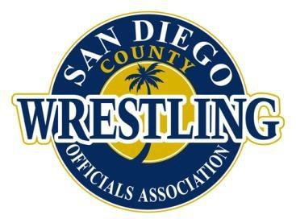
SDCWOA Official’s Fee Schedule 2026-2027 Season
Dual meet Fees
Varsity $86.00
Below Varsity $70.00
Combined $156.00
Exhibition Matches $6.00
Tri-Dual & Quad Dual Fee
- Minimum 3 hrs based on CHSSO Winter Officials Fee Schedule
- Time begins @ skin checks (if official is there) or scheduled start time, whichever is first
- Officials assigned under "Tournament Officials Guidelines" stated below
Fractional hours (over 3 hrs) rounded to the next 0:30 minutes (i.e. 8:10 pm rounded to 8:30 pm, 8:50 pm rounded to 9:00 pm)
Assigner Fees (per assignment)
Duals---$5.00 Tri/Quad---$6.00 1-Day Tourn---$8.00 2-Day Tourn--- $11.00
Individual Tournament Fees
Varsity $41.00/Hour
Below Varsity $38.00/Hour
Grooming Official $50.00
  - Overtime after 8 hours at a rate of 1½ times the above hourly rate.
  - Hourly pay starts at posted start time of wrestling.
  - All released officials are guaranteed at least 4 hours of pay.
Team Tournament Fees
Varsity $64.00/per-Dual
Below Varsity $55.00/per-Dual
Grooming official $50.00
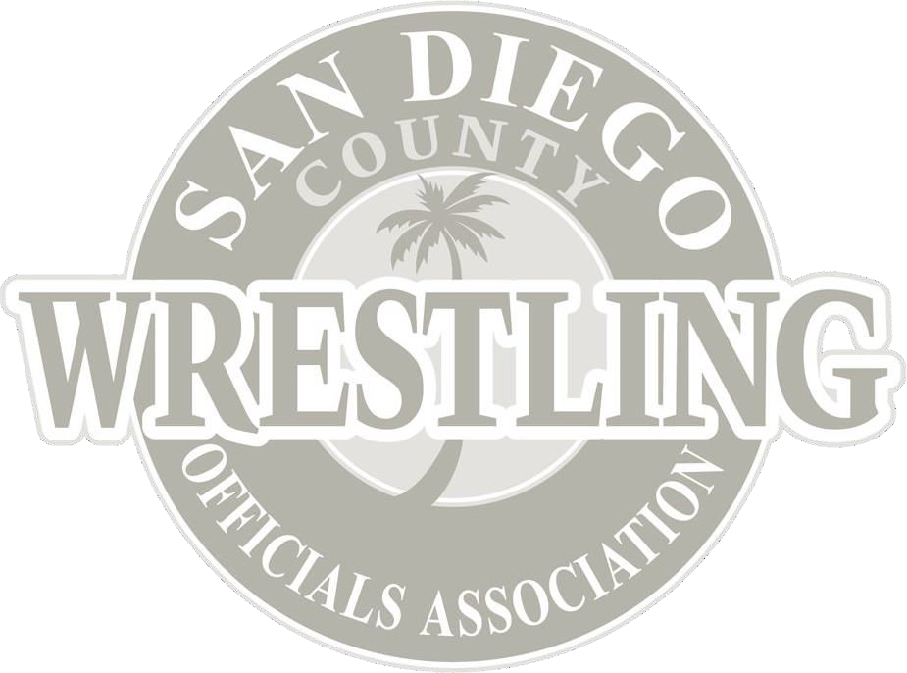
    - All released officials are guaranteed at least two Dual meets pay. Tournament Officials Guidelines:
Number of Mats Required Number of Officials
8 12
7 10
6 9
5 8
4 6
3 5
2 3
- The number of officials for finals will be 3 per mat when an assistant referee is used or 2 per mat when there is no assistant official.
- Payment will be based on number of officials required per formula, regardless of number
of officials assigned.
- In hourly paid tournaments, mat reduction will allow for adjustment to the number of officials to be paid from that point on.
- Once a mat is closed and officials are sent home, that mat will remain closed. If it becomes necessary to re-open a mat(s), the remaining officials will be paid according to the formula for the remainder of the tournament.

